Stage 5 – and the German will fear us
COURSE DESIGNER: Ike Starnes
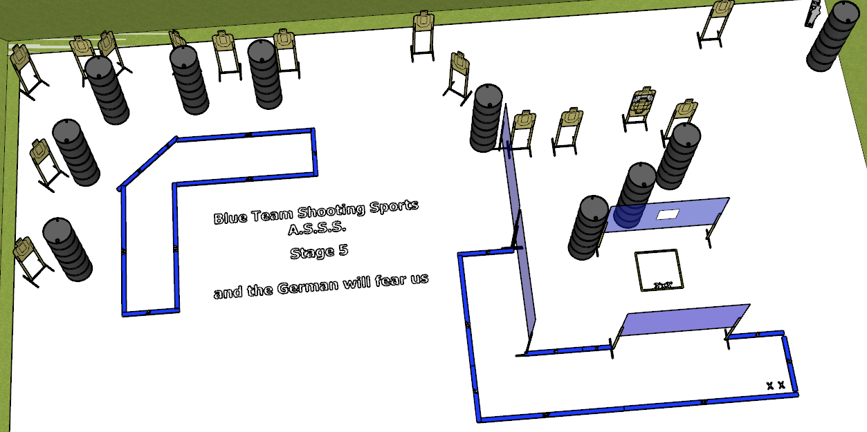

Written Stage Briefing:
Stage 5 – and the German will fear us is a 33 round, 165 point, Comstock course. There are 16 cardboard targets and 1 steel target. The best 2 hits per cardboard target will be scored. The steel must fall to score.
Start position Both feet on the Shooting Sports Innovations Xs.
Handgun: Loaded and holstered, wrists below belt
PCC: Loaded, stock touching belt
On the audible start signal, engage targets from within the shooting area.

